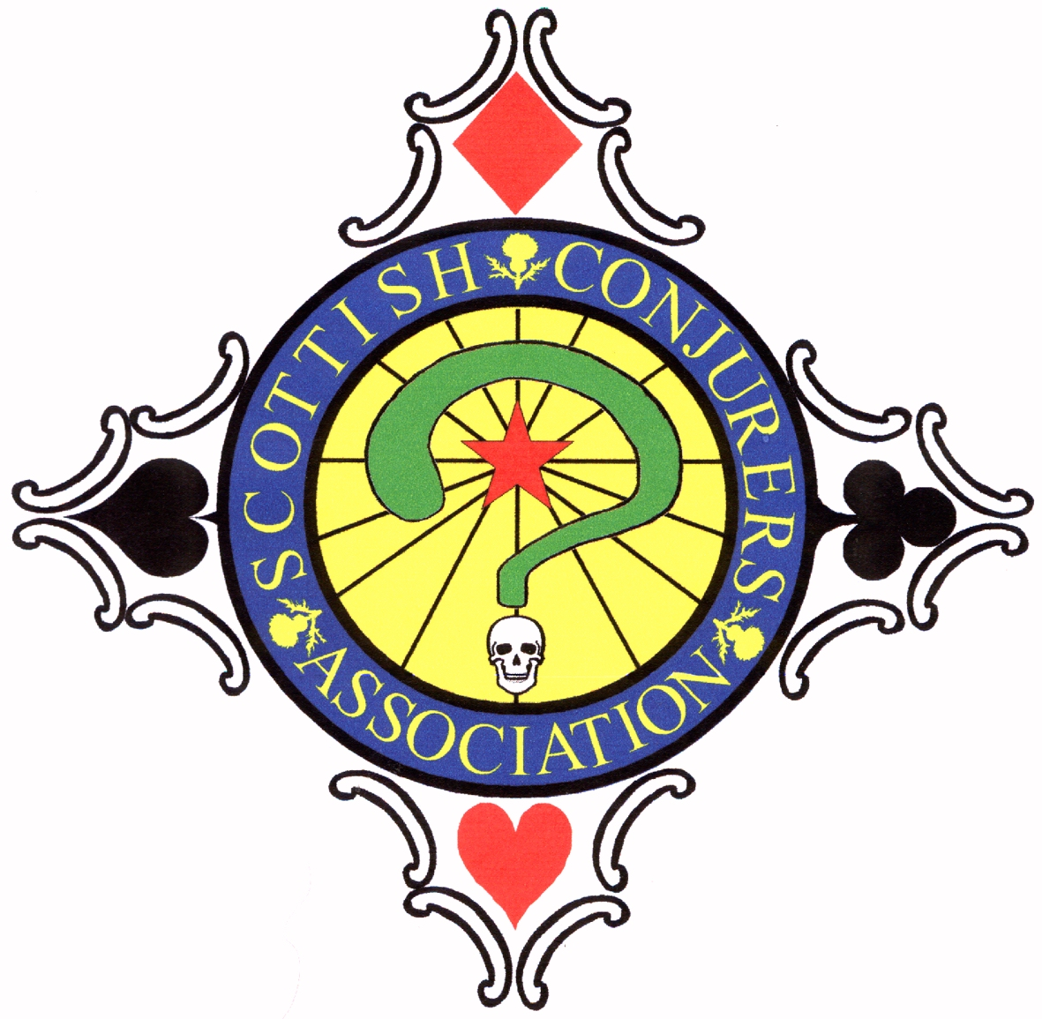

The Scottish Conjurers’ Association

Application for membership

I,_____________________________do hereby make application for admission to the membership of the SCOTTISH CONJURERS’ ASSOCIATION, on the understanding that:

- I shall not wilfully expose, either by word or by deed, any secret of magical significance before any person or persons who do not take an active interest in the Art of Magic.

- I shall not perform in public any effect, which is the exclusive property of another, unless I have previously obtained permission from the originator to do so.

Please give the following particulars for our records

Full name_______________________________________________________
Address _______________________________________________________
E-mail address___________________________________________________

Phone No____________________ Date of Birth________________

Professional Name if any_________________________________________
Occupation____________________________________________________
Approximate Date you began the study of Magic______________________
Please tick here if you do not wish contact details to be released to other members on request [ ]

The undersigned members, being satisfied as to the bona fides
and interests in magic of the applicant, do hereby recommend him/her for membership.

Signed 1________________________________ Date________________________
Signed 2________________________________ Date________________________

Interview result__________________________ Date________________________
Fees paid_______________________________ Date________________________
Initiation Date___________________________Signed_______________________

Initial (One-off) Joining Fee £15.00
Annual Membership Fee £45.00
Junior Membership (under 18) £25.00
Country Membership Fee (living 30 miles outside of Glasgow) £25.00

November 2011

